What is Bela?
Bela is an open-source embedded computing platform for creating responsive, real-time interactive systems with audio and sensors. It features ultra-low latency, high-resolution seneor sampling, a convenient and powerful browser-based IDE, and a fully open-source toolchain that includes support for both low-level languages like C/C++.
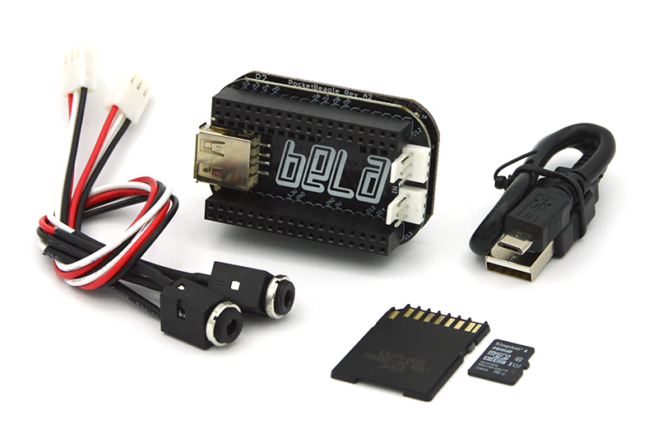
There is ready made hardware based on the Beagle single-board computers. The Bela software extends the functionality of the Beagle systems by integrating audio processing and sensor connectivity in a single, high-performamce package.
Bela comes with excellent online tutorials explaining how to use and program the system. Tutorial 13 introduces the concept of the finite state machine modelling a metronome and debouncing buttons.
It it really worth watching the tutorial video and doing the exercises.
Have fun with BELA!

